**Ideation Phase**

**Brainstorm & Idea Prioritization**

|  |  |
| --- | --- |
| Date | 30/10/2025 |
| Team ID | NM2025TMID00420 |
| Project Name | Streaming Ticket Assignment System For Efficient Support Operations |
| Maximum Marks | 100 |

**Brainstorm & Idea Prioritization Template:**

**To streamline ticket workflows effectively, it's essential to begin with a structured brainstorming process that identifies pain points and opportunities across automation, user experience, governance, and analytics. Once ideas are gathered, they should be evaluated based on feasibility and impact, allowing teams to prioritize quick wins and strategic improvements. By mapping these ideas onto a prioritization matrix, stakeholders can visualize which initiatives offer the greatest return with minimal effort. The final step involves assigning ownership, setting timelines, and defining success metrics to ensure each initiative drives measurable improvements in ticket resolution, routing accuracy, and overall support efficiency.**

**Step-1: Team Gathering, Collaboration and Select the Problem Statement**

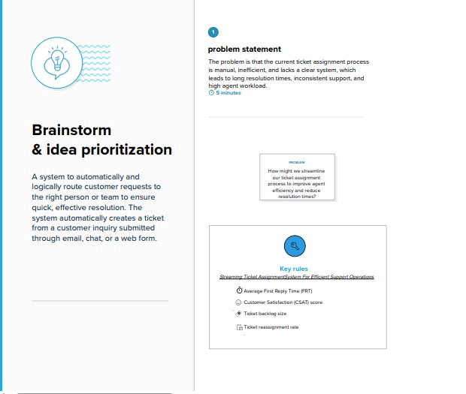

**Step-2: Brainstorm, Idea Listing and Grouping**

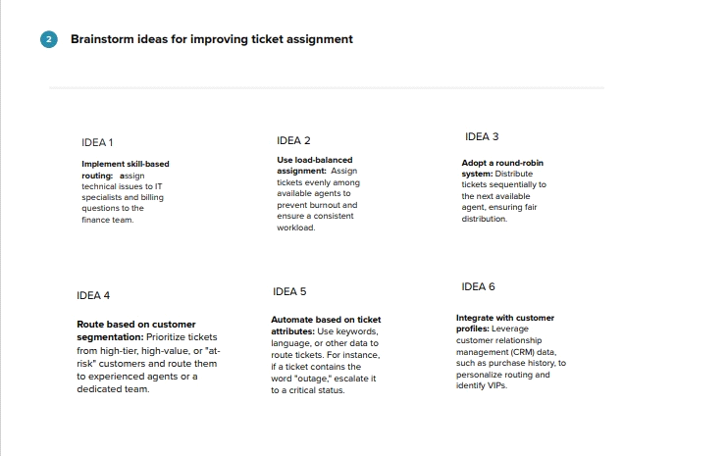

**Step-3: Idea Prioritization**

